**SMART MIRROR FOR FACE RECOGNITION AND VOICE ASSISTANT**

**INTRODUCTION**

Effective time management is an essential factor in increasing the production of day-to-day life. Integration of technology into people’s daily lives has made that time management possible. The use of products such as tablets, PCs, and smartphones have given people access to the tools needed to be productive. However, though successful technological products have been used to increase productivity, the use of technology has become another task in everyone’s daily to-do list. Technology should mold to our schedule, not the other way around. That is where the "Smart" mirror idea originated. "Smart" mirrors have been envisioned for years, part of the broader trend in imbuing everyday objects with various "smarts" to improve our lives. The smart mirror idea aimed to integrate technology seamlessly into people’s lives by putting it where everyone’s routine eventually collides. Hence, our ideology is to convert the traditional looking mirror into a smart mirror. We propose a smart mirror which is interactive and one can be well informed with the notifications being displayed through widgets and real-time updates. Doesn't it feel good to know more from a mirror rather than just yourself? The date, weather, time and the local news can be accessed just at one shot instead of pulling out some other secondary devices like phones, tablets or even the newspapers. This will save a lot of time and will keep you more informed before you start your day. Intelligent mirrors will take its place in the future technology and will provide both mirror and computer-aided information services to its users.

The goal of the smart mirror is to increase a user’s productivity by saving them time. Household Smart Mirrors: In consumer applications, the core function is basically twofold: Be a general informational hub, derived from viewing one's reflection as well as augmented with other useful information and provide some style and comfort benefits, in addition to mirror reflectivity and other functions. The smart mirror has the necessary applications and features needed for time efficiency focused device. First, there is the easy on and off. The mirror automatically recognizes that there is a user present and turns on the screen hidden behind the two-way mirror.

**SYSTEM ARCHITECTURE AND COMPONENTS**

A smart mirror is a two-way mirror with an electronic display behind the glass. The display can show the viewer different kinds of information in the form of widgets, such as weather, time, date, and news updates.

A “Smart Mirror” is a device that acts as a traditional mirror while also superimposing informational data, which can be customized by the user. The mirror also allows for touch free user interaction with some of the data displays by using face and voice recognition. Users are able to customize the visual interface to display what specific data feeds they want.

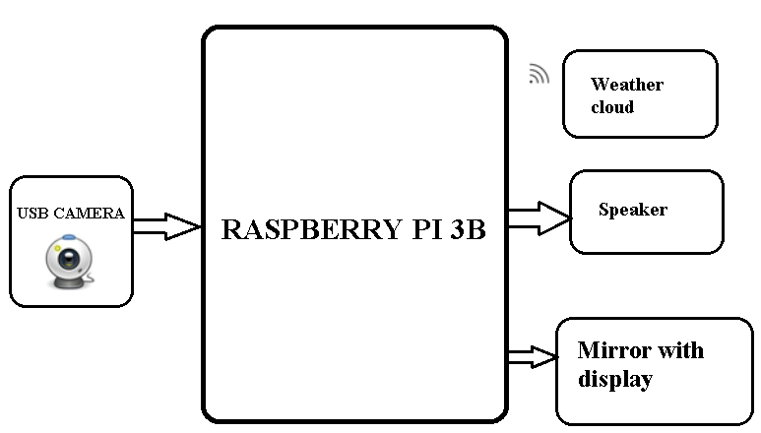

Basic block diagram of smart mirror

By using raspberry pi 4 which is the CPU of the smart mirror which displays the contents onto the mirror. Camera and speaker are connected to the raspberry pi 4.

**Components required for a smart mirror (software and hardware):**

* Raspberry Pi 3 B
* LCD Display *(19’’ inchs)*
* ONE-WAY Mirror *(20’’ * 20’’ inchs)*
* HDMI to VGA converter
* Wooden strips *(framework)*
* 1080 HD USB Webcam *or* PI-cam
* USB SPEAKER (8 kHz to 96 kHz)
* Developing tool: Python 3.7
* Node JS
* Raspbian OS
* OpenCV

 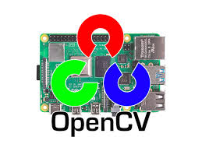 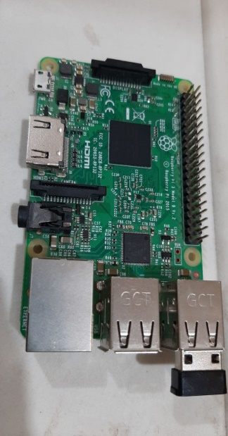

**ALGORITHM**

**Smart Mirror as a Mirror**

We can see our view as we can see it in a natural mirror while looking and grooming with the help of one-way mirror with high concentration of aluminum content.

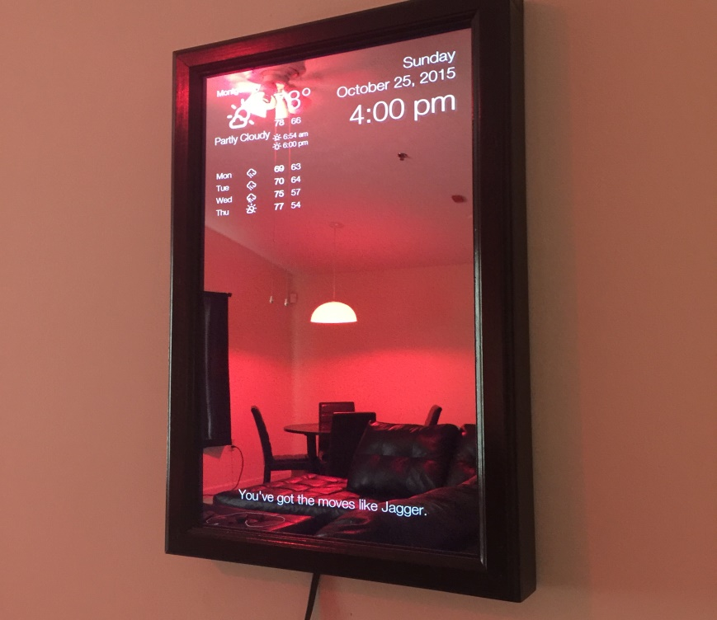

**Smart Mirror as an Information**

System Time, Date, weather details and news are fetched from online using predefined URL. News is fetched from websites like CCN, BBC etc.

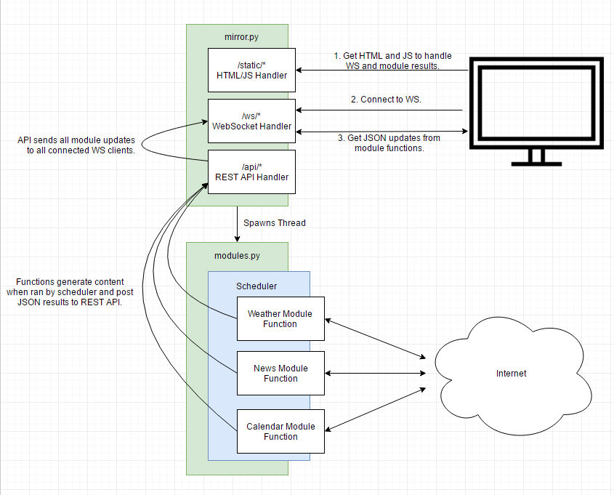

**Steps for Information System**

• Step 1: Switch on the power supply.

• Step 2: Get the date, time, and weather details from predefined from URL.

• Step3: Get the news from [www.thehindu.com](http://www.thehindu.com)

• Step 4: In code section write down all the compliments to be displayed on mirror.

• Step 5: Display it on mirror via LCD monitor

• Step 6: Switch off the power supply when it is of no use.

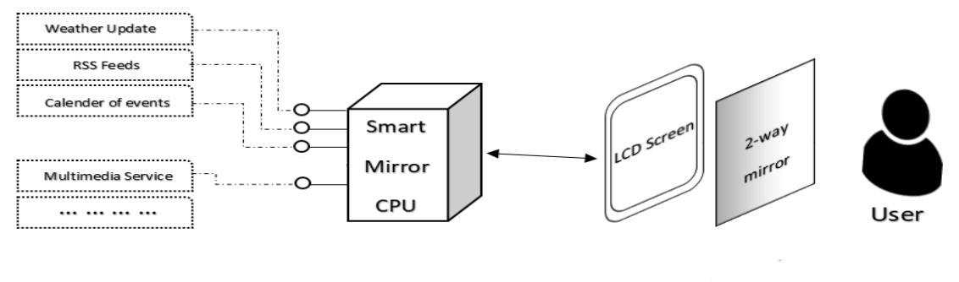

System Architecture of Smart Mirror

**Smart Mirror as a Personal Assistant**

* Setup a web camera in front of a mirror and connect it to the raspberry pi board.
* Write down the code for face detection in the raspbian software.
* Check if the face detection is taking place and with it the probability of the face detection.
* Provide the personal information such as messages, emails etc. by linking it with the social media API’s.

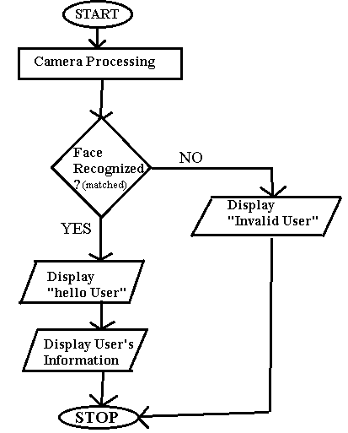

**Smart Mirror as an AI Voice Controlled Interaction**

* Make Smart Mirror work as voice-controlled AI device by ALEXA (artificial intelligence).

**APPLICATIONS**

Smart mirrors have many applications in both personal and social.

**In personal:**

* It can be used to display relevant information.
* Control household appliances
* Provide emotional support to users.
* In bathrooms, smart mirrors could prove to be a valuable application for many people
* Breaking news show up on their smart mirrors seamlessly.

**In social:**

* It can be used for advertisements and emergency alerts
* Installed in ﬁtting rooms, a smart mirror could revolutionize clothes shopping.

**ADVANTAGES**

* Useful for multi-tasker
* Fast and easily accessible
* Easily portable
* Customizable UI
* Easy to assemble

**NOTE:**

As we have extended our mini project to major project, we had some issues during mini project which we have rectified. The issues which we have faced are as follows:

* Security
* Not a Touch free interface
* Power consumption

In our major project we overcame the above issues by using a web camera and voice assistance.

* By using webcam, we enabled face recognition for the security purposes.
* By using of the voice assistance, we have created a touch less user interface.
* And power consumption was reduced by webcam as the mirror display only if you’re an authenticated user or will be in sleep.

**CONCLUSION & FUTURE SCOPE**

* This documentation is about the smart mirror project. This stemmed from the need for better time management and productively along with the inspiration of new, developing technologies now available. The smart mirror idea was created to give instant access to information in a convenient and time-saving environment, the living room. All other aspects of the mirror’s design developed from these ideas and inspirations. The goals of the smart mirror were to aim to reduce the time needed in a user’s daily routine and provide a merger of user and technology that becomes an enhancement, not a new burden. The functionality must meet these descriptions in the design. The smart mirror did the thinking for the user with intelligent, commonly used applications. Apps like their calendar, music, news, Twitter, to-do lists, and weather will be available. The apps were unobtrusively displayed on the screen, hidden by the two-way mirror, as to look like a seamless experience. Once enough information was collected about specifications and prices, strategic components were selected to be part of the project from both a hardware and software perspective. The hardware components included the central PC components, the webcam with mic, speakers, and Raspberry Pi. After research, the design phase was started. This included multiple subsystems which ranged in various difficulties and depth of design. One of the easier subsystems to design was the gesture control subsystem. The final stages of the project, and document covered how the mirror was approached in terms of prototyping and testing**.** In Future, we will investigate how the surrounding context of the user and the environment can be utilized in order to provide optimal experiences. We, can be able to control Home appliances and lighting, even when we are getting ready for the day.